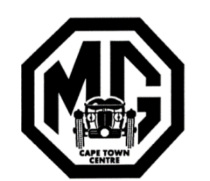 | Car Details  MG Car Club - Cape Town Centre  9 Riebeeck Street, Wynberg, 7800  mgccct@gmail.com
CAR DETAILS for the CLUB REGISTERS Date:
Please enter the below details as applicable to your car and return this form with a recent colour photo to:
Register Secretary, MG Car Club, 9 Riebeeck Street, Wynberg, 7800 or e-mail as an attachment to mgccct@gmail.com
Name:
Address & Code
Ph. no. & Cell No.
E-mail
MG Type / Model & year
Engine : Prefix & number
Chassis : number
Body : number
Durban Motor Assemblies No.
(if applicable)
License : Reg. Number / if applicable
Colour : Body & Trim
Wheels : spokes, disc, mags,
Rostyle etc
Condition : Underline as applicable | Original Restored Being Restored to be restored Incomplete
Date when purchased by you
Previous owner / s (if known)
History of the car (if known)
Modifications : or other details of interest
Colour photo attached if available | yes | no
Should assistance be required in completing this information please contact mgccct@gmail.com

